**Practical No. 2: Write a program to design a form using the components List and Choice.**

**Exercise 1: Develop an applet/ application using List components to add names of 10 different cities.**

**Program:**

import java.applet.*;

import java.awt.*;

/*

<applet code=pract2_ex1.class width=300 height=200></applet>

*/

public class pract2_ex1 extends Applet

{

public void init(){

List l1 = new List(10);

l1.add("Mumbai");

l1.add("Pune");

l1.add("Banglore");

l1.add("Delhi");

l1.add("Noida");

l1.add("Gurgaon");

l1.add("Hyderabad");

l1.add("Indore");

l1.add("Jaipur");

l1.add("Surat");

//l1.add("extra city");

add(l1);}}

**Output:**

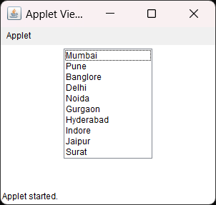

**Exercise 2: Develop applet / application to select multiple names of news papers.**

**Program:**

import java.applet.*;

import java.awt.*;

/*

<applet code=pract2_ex2.class width=300 height=200>

</applet>

*/

public class pract2_ex2 extends Applet

{

    public void init()

    {

        List l1 = new List(7,true);

        l1.add("Times of India");

        l1.add("Hindustan Times");

        l1.add("The Hindu");

        l1.add("The Economic Times.");

        add(l1)

    }

}

**Output:**

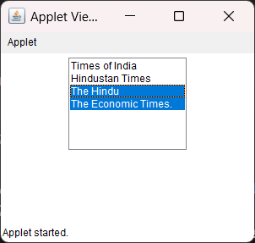

* **Write Java Program to show following output.**

**Program:**

import java.awt.*;

import java.applet.*;

public class pract2_X extends Applet

{

    public void init()

    {

        List l1 = new List(3,true);

        l1.add("Summer");

        l1.add("Winter");

        l1.add("Rainy");

        add(l1);

    }

}

/*

<applet code=pract2_X.class width=300 height=300>

</applet>

*/

**Output:**

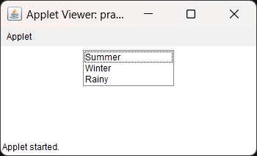

* **Program:**

import java.awt.*;

import java.applet.*;

public class pract1_XII extends Applet

{public void init()

    {Choice ch = new Choice();

        ch.add("Maths");

        ch.add("Physics");

        ch.add("C++");

        ch.add("Java");

        add(ch);

    }

}

/*

<applet code=pract1_XII.class width=300 height=300></applet>

*/

**Output:**

